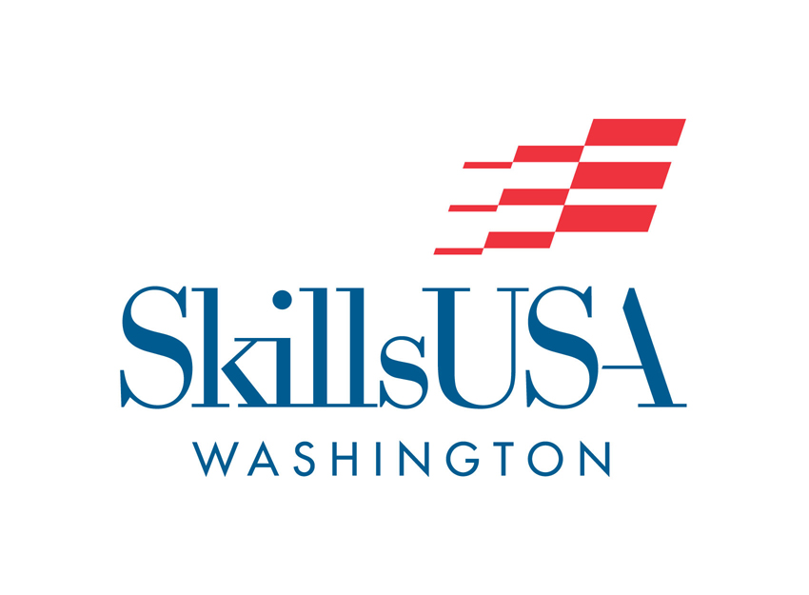
2016-2017
Program of Work
“SkillsUSA Champions at Work:
Preparing America’s Skilled Workforce”
Secondary Division
Middle Schools
High Schools
Skill Centers

2011-2012 Program of Work

2016-2017 Events Calendar
Date Event
September 17 Puget Sound Region Advisor Mtg – Bellevue HS, 9-noon
September 17 Washington Leadership Training Institute – Advanced Training, WA DC
September 20 Southwest Region Advisor Meeting – Skyview High School (4:30 PM)
September 21 Eastern Region Advisor Meeting – NEWTECH Skills Ctr (5:00 PM)

October 6 Olympic Region Advisor Meeting – Roosters - Shelton (5:00 PM)
October 11 Board of Director’s Meeting LOWES (10AM)
October 20 Puget Sound Fall Leadership Conference
October 20 Central Region Advisor Meeting – Yakima Valley Skill Center (5pm)
October 25 Easter Region Fall Leadership Conference (9-1pm)
October 29 Southwest Region Fall Leadership Conference – Fort Vancouver HS (10am)

November 3-5 Chapter Officer/Leader/Advisor Training-CISPUS Learning Center, Randle, WA
November 3/4 State Conference Planning Meeting & Pin Design Planning
November 4 Become a SkillsUSA trainer for your region, Randle, WA – Adam Scroggins
November 4 Prepare your students to compete – competitions in the classroom – Adam Scroggins
November 14 1st Semester Membership Deadline

December Lowes Grants Applications Due (if sponsor funding secured)
January 27 State Pin Design Submissions Due / State Program Cover submissions due

February National CTE Month
February 3 NLSC Pin and NLSC T-Shirt Deadline
February 1 CTSO Legislative Day State Capital Building & Legislator visits 8am
February 4 Olympic Region Leadership Conference – Aberdeen High School
February 5-11 SkillsUSA Week
February 10 Advisor of the Year Application Due
February 10 Chapter of Excellence submissions due
February 11 Final Membership Deadline for National Competition
YOU MUST BE A MEMBER BEFORE YOUR REGIONAL COMPETITION
February 11 Regional Contests completed
February 11 Puget Sound Leadership Competitions – Pierce County Skills Center
February 17 All Regional results due to Contest Coordinator
February 24 Board of Director’s Meeting – LOWES – 10am-noon
February 24 State Selection Mtg (State Directors & Regional Coordinators) 12:30-3:30 LOWES

March 1 State Contest Invitation List Distributed
March 12-14 State Officer Training – Black Lake Bible Camp
YOU MUST BE A MEMBER BEFORE YOUR REGIONAL COMPETITION
March 24 State Conference Hotel & Registration deadline (to be confirmed)
March 27 CTE Showcase of Skills (Tiny Houses) – Olympia, WA

April 3 President’s Volunteer Service Award Applications Due/received (skillsusa.org)
April TBD Sharon Melton Meyers Memorial Scholarship Applications Deadline
April 21-22 Post-Secondary SkillsUSA Spring Conference – Pasco – Columbia Basin College
April 27- 29th State Leadership & Skills Conference (SLSC) – Yakima Convention Center

May 1 International SkillsUSA Degree Application Deadline
May TBD SkillsUSA Alumni & Friends Merit Scholarship Application Deadline
May 21-24 State Officer Training – Warm Beach, Stanwood
May 23 Board of Director Meeting – Warm Beach, Stanwood 10am
May TBD Mike ROWE NLSC Scholarship Applications due

June 17-19 Leverage, Activate and Engage Training, Louisville, KY
June 19-23 National Leadership & Skills Conference (NLSC) – Louisville KY

August 6-9 WA-ACTE Summer Conference
August 16-20 SkillsUSA State Director’s Conference – San Diego, CA
August 22 Board of Director’s Meeting – Yakima - 11am

Greetings from your State Director!
Dear SkillsUSA Advisor:
Greetings and best wishes for your 2016-17 school-year. May it be filled with positive activities and experiences as well as personal and professional growth.
I continue to gather stories from your chapters and best practices from other SkillsUSA Director’s to improve the guidelines we provide to our chapters. We’ve made updates to our by-laws, constitution and competition policies. I believe they are all works in progress and should be continually reviewed.
Our membership continues to grow as we add new chapters across our state. To those new programs, welcome! I hope you will reach out for support and that our experienced advisors can share what works for their schools and communities.
I am excited for our move to Yakima for our state conferences in 2017, 2018 and 2019. Moe Broom and Brandon Hirst will coordinate our technical contests and Debbie Evans our leadership contests. Our contest coordination team is already working hard to ensure quality contests for our state competitions.
Adam Scroggins will continue as an official state certified SkillsUSA Trainer. Adam was certified to provide this training and continues to get excellent reviews providing training to advisors across the state. Feel free to request training in your area.
Karmen Ayres and Riley Johnson, State Officer Trainers, are continuing to work with our State Officer’s and have planned out some great training and community service projects to develop their leadership skills and plan our state conference.
Continued thanks to our regional coordinators Ray & Linda Cyr (Central), Brandon Hirst (Eastern), Keith Kuniyasu (Olympic), Adam Scroggins and Joani Bishop (Puget Sound), Riley Johnson and Karmen Ayres (South West) and our Board of Directors. Terri Lufkin
Contact Information
SkillsUSA Washington - P.O. Box 2698, Olympia, WA 98507 - www.skillsusawashington.org

State Director Executive Director
Dennis Wallace, OSPI/Skilled & Technical Terri Lufkin
Science Pathway Supervisor Office/Cell Phone: 360.904.8578
Phone: 360-725-6241 Email: tlufkin@comcast.net
Email: dennis.wallace@k12.wa.us Email: terri.lufkin@skillsusawashington.org

Central Region Coordinator Olympic Region Coordinator
Ray & Linda Cyr (Davis High School) Keith Kuniyasu (River Ridge High School)
Phone: 509-573-2770 Phone: 360-412-4411 Ext. 42524
Email: cyr.raymond@yakimaschools.org Email: kkuniyasu@nthurston.k12.wa.us
Email: cyr.linda@live.com
Eastern Region Coordinator Puget Sound Region Coordinator(s)
Brandon Hirst (NEWTECH Skill Center) Adam Scroggins
Phone: 509-354-7423 Phone: 253.683.5963
Email: BrandonH@spokaneschools.org Email: ascroggins@bethelsd.org

Southwest Region Coordinator(s) Joani Bishop (ACE @ The Tyee Complex)
Phone: 360.608.3826 Phone: 206-631-6473
Email: ayres.karmen@gmail.com Email: Joani.bishop@highlineschools.org
swregionalcoordinators@gmail.com
Teri Bravomejia
Riley Johnson Email: tbravomejia@asd.wednet.edu
Email: rileygjohnson@gmail.com Phone: 619-277-1923

Contest Coordination Team
Moe Broom Brandon Hirst
Email: broom.moe@yakimaschools.org Email: bhirst@gmail.com

Debby Evans (Leadership Competitions)
Phone: 360.947.4487
Email: dgevans@gmail.com
Board of Directors

Andrew Berhow – President & SW Region Rep.
Brandon Hirst – VP & Eastern Region Rep.
Jay Leviton – Renton School District
Dennis Wallace – OSPI
Terri Lufkin – SkillsUSA Washington
Elmer Arter – Labor & Industries
Cindy Gaudio – Carpenter Training Center
Paul Ringstad – Universal Technical Institute
Glenn Grossenbacher – Snap-on Industrial
Donald McMichael – Lowes
Joe Michalak – Naval Shipyard
Reuben Farley – Naval Shipyard
Ed McVoy – State Farm
Monty Prather – SkillsUSA Washington P.S.
Raymond & Linda Cyr – Central Region Rep.
Adam Scoggins – Puget Sound Region Rep.
Tyler Renz – Olympic Region Rep.
Toni Pridemore – SkillsUSA State President
Moe Broom – WAVA Representative
Tracey Scharmann - Treasurer

Meet Your SkillsUSA Washington 2016-2017 State Officers
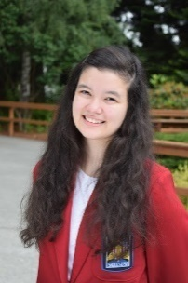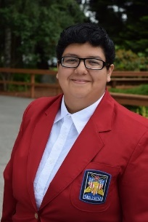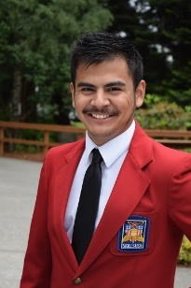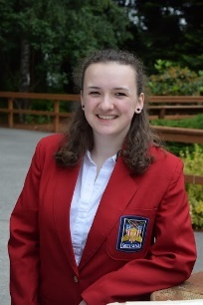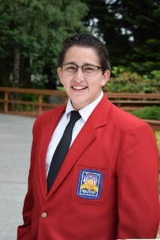
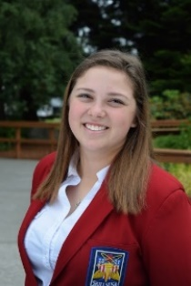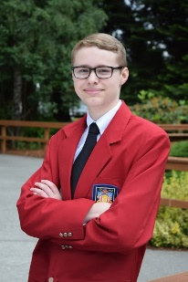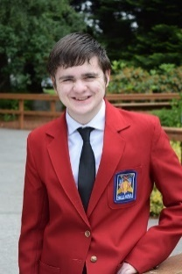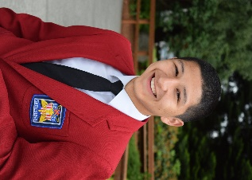
(Top to bottom - Left to right) Toni Pridemore: President – Fort Vancouver HS, Ashley De La Garza: Vice President – Davis HS, Jose Enriquez Campos: Treasurer - Davis HS, Megan Bina: Secretary – Vancouver School of Arts and Academics, Henry Bravomejia: Parliamentarian – Arlington HS, Nadia Wirta: Historian/Reporter – Aberdeen HS, James Hill: State Representative - Lewis and Clark HS, Jacob Hope: State Representative – River Ridge HS, Edgar Ramirez: Sergeant at Arms – Fort Vancouver HS
SkillsUSA National Officers 2016-2017

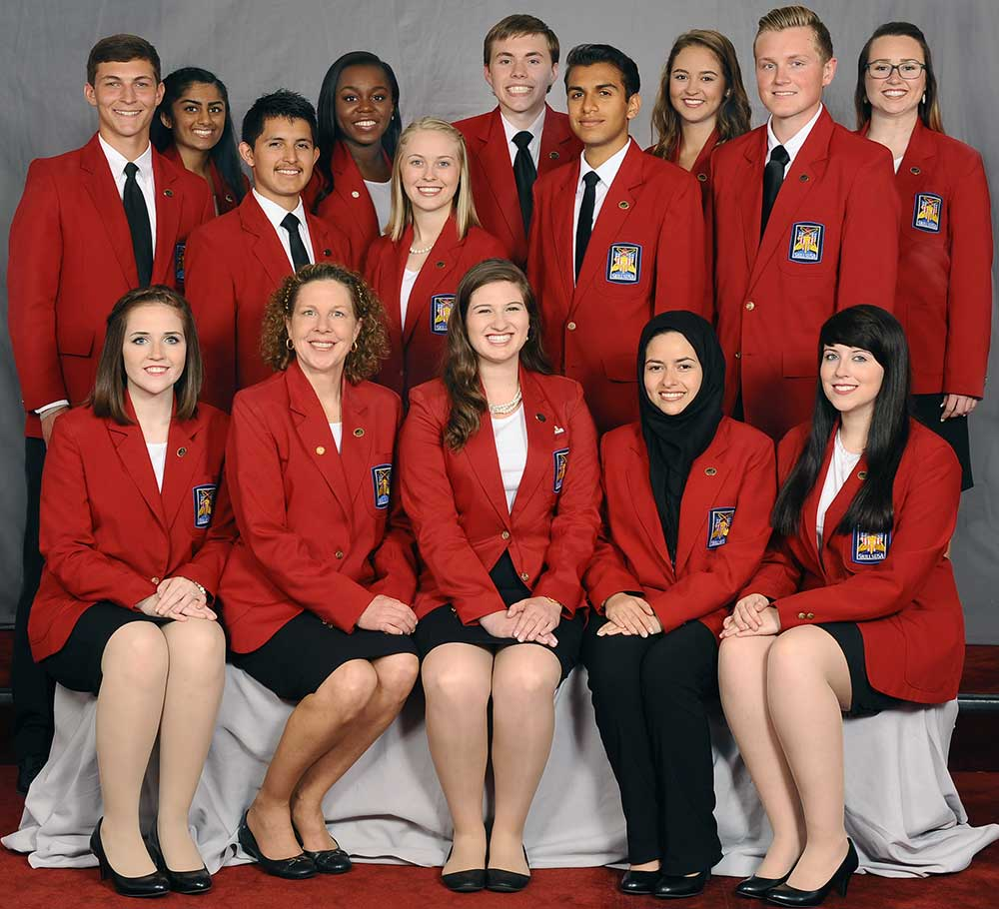

Membership Dues & Registration

SkillsUSA Washington membership registration will be completed through the SkillsUSA website. To join SkillsUSA, go to: www.skillsusa.org/join or www.skillsusa-registger.org if you have previously been a member. Please provide accurate, up to date email to receive membership incentives. When you register you receive an email with the code to enter into the database to access Technical Standards, Jump in STEMP and Career Readiness Curriculum (CRC). The CRC can help ensure students are being prepared for workplace success. CRC supports the framework of the SkillsUSA mission, which includes personal, workplace and technical skills grounded in academics – all essential to a successful, student-oriented career and technical education program. This curriculum includes 29 lesson plans and is based on Common Core State Standards and infuses 21st-century skills into student activities. Instructors who register with 100-perfect membership plus an advisor will receive a SkillsUSA Program of Work calendar.

Students must be registered members (prior to competition) in order to compete at regional, state or national competitions. Students must also be registered members to run for state or national offices.
Submit membership rosters early. New or additional students can be submitted as they enter the program or decide to join. State deadlines are prior to participating in your region’s leadership and/or technical contest and no later than February 11. National Deadline to compete in National competition is March 1, 2017. All dues (state & national) are to be paid to SkillsUSA (in Virginia). State dues are sent to the state by National SkillsUSA.

Dues are as follows:
Students: $16.00 ($8 State & $8 National)
Advisors/Professionals (Instructors, School Administrators & Advisory Committee Members): $28.00 ($8 State & $20 National). NOW INCLUDES TECHNICAL STANDARDS
Alumni: $5.00 (State Only)
Note: Some regions have additional fees or competition participation fees!

Contact National SkillsUSA for assistance with membership/dues registration and payments. Hotline Operators will support advisors and assist new schools. They work with advisors to help get started implementing SkillsUSA programs. Their email is: Operators@skillsusa.org and phone number is: 1-844-875-4557. For general membership questions and website technical support contact membership@skillsusa.org. Membership questions can be answered by calling the Membership Hot Line at: 800-355-8422. Tuesdays and Thursdays they are open until 7pm.
Advisor’s Incentive: Register 1 professional member and 15 student members by November 15th and you will receive a SkillsUSA Framework podium banner.
The Alumni Executive Board is offering an incentive for SkillsUSA advisors who sign up alumni from their chapters. For every five members an advisor registers with the SkillsUSA Alumni & Friends Association, he or she will be entered into a drawing for a $100 Lowe’s gift card. To be officially entered into the drawing, the advisor must have students register online at: www.skillsusa-register.org/alumni/welcome.aspx. (Paper forms will not be accepted.)
The advisor must then send an email to Byekwaso Gilbert at bgilbert@skillsusa.org. The email must contain all of the following:
- the advisor’s name, school, address, phone and email (make sure what you provide will be accessible to you after June 1)
- a list (for verification) of the students (first and last names) who registered as alumni
Remember that graduating seniors qualify to register during their senior year. Former SkillsUSA students are also eligible, provided they are not members already. These students must register through their former advisor to be counted as part of that advisor’s entry. Students may only register once.
Chapter Excellence Program (CEP)

The Chapter Excellence Program (CEP) honors chapter achievement relative to SkillsUSA’s framework of developing personal, workplace and technical skills. The framework actualizes SkillsUSA’s mission “to empower members to become world-class workers, leaders and responsible American citizens.” It also serves as the blueprint for career readiness – our ultimate goal as an organization. By centering on industry demands, the framework builds the foundation for relevant and intentional student learning and employability skill development. Application can be submitted by Chapter or by section. Your section or chapter can be recognized at State Conference as a Quality Chapter for achieving essential standards at the First Level. Second Level achievement is also recognized at the State Conference as Bronze, Silver or Gold Chapters of Distinction. Up to 10% of the Gold Chapter will be eligible for selection as a Model of Excellence Chapter and recognition at the National Conference by completing the Third Level.
Lowe’s Sponsors $2,000 Grant to Recognize Chapter Excellence @ NLSC (pending sponsorship)
The program consists of 4 award levels. The first three levels are recognized by the state and the final level eligible for national recognition. The 25 chapters selected as models of excellence will receive a $2,000 section or chapter grant to help offset expenses for SkillsUSA National Leadership and Skills Conference. Complete your CEP application online at: www.skillsusa-register.org/Login.aspx. If you have questions, contact Gayle Silvey at gsilvey@skillsusa.org or 404-216-6040.
Career Readiness Curriculum (CRC)

Each Professional SkillsUSA Instructor will receive the Career Readiness Curriculum. You will get a PIN # when you become a member so join early. This practical and flexible standards-based curriculum seamlessly integrates framework components into classroom instruction. It offers 29 user-friendly lessons that incorporate employability skills, engaging activities and proven teaching methods for effective learning. What’s more, it’s presented in a format that makes your job easier. The CRC was not written to be an add-on or a step-by-step process; it was written to merge the SkillsUSA Framework with what you’re already doing. It also presents career readiness in line with Common Core standards, and is based on information from the US Dept. of Education, US Dept. of Labor, Partnership for 21st Century Skills and the SCANS skills.

SkillsUSA Washington Contests - 2016-2017

Listed below are the contests offered at the National Level. State and Regional contests will differ depending on interest and contest management at those levels. Contests listed in “Red” below denote that this contest had no participants in the 2016 State Championships. All contests are conducted in accordance with the 2016-2017 National Skills Technical Standards. These standards should be reviewed prior to students competing in contests.

Skilled & Technical Science Contests

3-D Visualization & Animation Heating, Ventilation, Air Cond & Refrigeration
Advertising Design Humanoid Robotics (Demo)
American Sign Language (STATE ONLY) Industrial Motor Control
Architectural Drafting Internetworking
Audio/Radio Production Interactive Application & Game Development
Automotive Maintenance (STATE ONLY) Automated Manufacturing Technology Automated Manufacturing Technology Jewelry Design (STATE ONLY)
Automotive Refinishing Technology Major Appliance & Refrigeration Repair
Automotive Service Technology Marine Service Technology
Aviation Maintenance Technology Masonry
Basic Electronics (STATE ONLY) Mechatronics
Basic Health Care Skills Medical Assisting
Broadcast News Production Mobile Electronics Installation (Demo)
Building Maintenance Mobile Robotics Technology
Cabinetmaking Motorcycle Service Technology
Carpentry Nail Care
CNC Milling Nurse Assisting
CNC Technician Photography
CNC Turning Plumbing
Collision Repair Technology Power Equipment Technology
Commercial Baking Practical Nursing
Computer Maintenance Technology (STATE ONLY) Precision Machining Technology
Computer Programming Principles of Technology*
Cosmetology Residential Systems Installation & Maint
Crime Scene Investigation Restaurant Service
Criminal Justice Robotics & Automation Technology
Culinary Arts Robotics: Urban Search & Rescue (Demo)
Dental Assisting Screen Printing Technology
Diesel Equipment Technology Sheet Metal
Digital Cinema Production Technical Computer Applications
Early Childhood Education Technical Drafting
Electrical Construction Wiring Telecommunications Cabling
Electronics Technology Television (Video) Production
Engineering Technology/Design T-Shirt Design
Esthetics Web Design
Firefighting Welding
Graphic Communications Welding Fabrication
Graphic Imaging Sublimation (Demo) Welding Sculpture

Leadership Development Contests

Action Skills Job Skill Demonstration “A”
American Spirit Notebook Job Skill Demonstration “Open”
Chapter Business Procedure Occupational Health & Safety
Chapter Display Opening & Closing Ceremony
Community Action (Demo) Outstanding Chapter Notebook
Community Service Pin Design
Creed (STATE ONLY) Prepared Speech
Employment Application Process Promotional Bulletin Board
Extemporaneous Speaking Quiz Bowl
Job Interview Quiz Bowl – Automotive (NEW-STATE ONLY)

Occupationally Related Contests

Career Pathways Showcase Health Occupations Portfolio
Customer Service Medical Math
Entrepreneurship Medical Terminology
First Aid/CPR Related Technical Math
Health Knowledge Bowl

Note: Regarding State Level Contests, individuals may participate in more than one contest. A student may compete in up to three contests. (1) Technical Science Contest and either (2) Leadership Development Contests or (2) Occupationally Related Contests. If not participating in a Skill Contest, individuals may participate in a combination of 3 leadership and occupationally related contests. Individuals may participate in only one Technical Contest.
At the Regional Level, consult your regional coordinator.
At the National Level, students are limited to only one contest in any of the above categories.

Resources
Be sure to investigate all that SkillsUSA has to offer through the national website at: www.skillsusa.org and the Washington State website at: www.skillsusawashington.org. There is a large amount of helpful information available to start and manage a chapter, plan for leadership and skills conferences and contests, and prepare students through exciting events and activities. The information is there, tap into it. You do not have to reinvent the wheel, simply use the one provided. If you need chapter management assistance, simply contact the state executive director, regional coordinator or state officer.
SkillsUSA Scholarships
SkillsUSA Alumni Merit Scholarship May 1 Deadline
SkillsUSA Alumni and Friends Association is offering two merit-based $500 scholarships to qualifying students. The $500 scholarships will recognize the unique qualities of SkillsUSA students including leadership, commitment to community service, and advocating for career and technical education.
http://skillsusa.org/membership-resources/scholarships-financial-aid/alumni-friends-scholarship/

Culinary Institute of America National Student Organization Scholarship
31 one-time $3000 scholarships for active members of SkillsUSA. Separate scholarship for students who place strongly in culinary or baking and pastry competitions. http://www.ciachef.edu/scholarships-by-campus/

National Technical Honor Society Scholarships for SkillsUSA Members April 1 Deadline
The NTHS annually awards a $1,000 scholarships to two high-school SkillsUSA members and two college/postsecondary Skills USA members who are also involved in NTHS. For details go to: http://skillsusa.org/membership-resources/scholarships-financial-aid/national-technical-honor-society/

Robert Flint Student Leadership Development Scholarship
SkillsUSA members with financial needs may be eligible for a Student Leadership Development Scholarship to attend Activate and Leverage conferences in June or the Washington Leadership Training Institute (WLTI) in September. Four scholarships at $1,300 each will be awarded to attend Activate and Leverage training and four scholarships at $800 will be awarded to attend WLTI. Nominations can only be made by a state association director. For details, contact Terri Lufkin or Denny Wallace.

Manufacturing Institute Scholarship Program
Full-tuition scholarship toward a bachelor’s or master’s degree in a manufacturing-related degree program at University of Phoenix. www.phoenix.edu/mischolar

Collision Repair Education Foundation Scholarship
Secondary and post-secondary collision students attending career and technical schools and colleges have the opportunity to apply for the over $200,000 in available scholarships and tool grants available through the Collision Repair Education Foundation and the organization’s industry supporters. For details and application http://collisioneducationfoundation.org/student-scholarship-and-grant-application-2016/

mikeroweWORKS Foundation Competitor Scholarship May 27, 2016 deadline
This scholarship is to provide support for SkillsUSA State contest winners who have insufficient personal, chapter, school or community resources to participate at the 2016 Nationals SkillsUSA Championships. $1000. http://skillsusa.org/membership-resources/scholarships-financial-aid/the-mikeroweworks-foundation-competitor-scholarship/

Sharon Melton Myers Memorial Scholarship April 30th Deadline
Through a donation from the Sharon Melton Myers Memorial Fund, SkillsUSA and the McMinn County Vocational Center SkillsUSA Alumni Association are offering a $500 scholarship to a SkillsUSA member for continuing education in college or technical school. Visit: https://skillsusa.wufoo.com/forms/sharon-melton-myers-memorial-scholarship/

SkillsUSA Championships
The following scholarships are offered through the SkillsUSA national office to winners of SkillSUSA Championships. Most scholarships are awarded to first, second and third place medal winners. In most cases, these scholarships are applied directly to tuition and education expenses. Medalists also receive tools of the trade, software and other awards. For complete details, go to: www.skillsusa.org/students/scholarships.shtml

International SkillsUSA Degree
Students who successfully complete the International Degree of the PDP are eligible for a $1000 travel scholarship to attend the National Conference. Applications are due May 1st. Send letters and accompanying materials are to: International SkillsUSA Degree Review Committee, c/o SkillsUSA, 14001 SkillsUSA Way, Leesburg, VA 20176

Lowe’s Schools In Need & Career Safe Grants
Vouchers allow students to take online assessment and earn OSHA 10 hours Construction or General Industry Safety Credential.

Lowe’s Schools in Need Grant
Provide basic needs to improve the quality of students’ education experience. Grants between $2500 and $25,000 are available. Go to http://www.skillsusa.org for more information and to secure an application. Applications must be received by December 20, 2016. Recipients from the previous year are not eligible.

Image Contest
SkillsUSA Champions magazine features our members’ photography. We’re looking for images of SkillsUSA Chapters in action, or the kind that show individual members’ concentration or perseverance. The photographer’s chapter will be awarded $150 for a winning entry. For additional information, email Tom Hall, thall@skillsusa.org or write: SkillsUSA Champions, 14001 SkillsUSA Way, Leesburg, VA 20176

2016-2017 National SkillsUSA Competition Theme
The SkillsUSA competition theme for the 2016-17 year is: SkillsUSA: Champions at Work: Preparing America’s Skilled Workforce
The topic to be addressed by contestants in the Chapter Display, Prepared Speech and Promotional Bulletin Board competitions is how our theme, SkillsUSA: Champions at Work, Connecting You to Career Success, addresses the SkillsUSA national program of work in the area of professional development.

Within this topic, contestants might illustrate or discuss any of the following:
- How is SkillsUSA an integral part of your career and technical education program so that it ensures you are prepared for America’s skilled workforce?
- How has your involvement in SkillsUSA made you a more sought-after employee than your peers who aren’t members?
- If a potential employer asked you which specific skills gained from SkillsUSA have made you better prepared for America’s workforce, what would you say?
- If asked to create a member recruitment campaign around the fact that SkillsUSA is preparing America’s skilled workforce, what would be your key points?
- Why is the SkillsUSA Framework of developing personal, workplace and technical skills central to the concept of preparing America’s skilled workforce?
- Why is ensuring that the United States has a skilled workforce important for the global economy?
- What are the ramifications if the United States does not have a skilled workforce?
- In the next 10 years, what skills are needed to fill the job-market skills gap, and how do SkillsUSA members ensure they are prepared through their SkillsUSA involvement?
- How has your involvement in SkillsUSA ensured that you will be prepared to enter America’s skilled workforce?
- What elements of SkillsUSA ensure that members are prepared to enter America’s skilled workforce?
- What specific skill development is helping you fulfill the mission of SkillsUSA: to empower its members to become world-class workers, leaders and responsible American citizens?
- Which SkillsUSA programs ensure that members are developing the personal skills needed to be prepared when entering the workforce? Program examples may include those that improve the following: integrity, self-motivation, work ethic, professionalism and responsibility.
- Which SkillsUSA programs ensure that members are developing the workplace skills needed to be prepared when entering the workforce? Program examples may include those that improve the following skills: communication, decision making, teamwork, cultural sensitivity and leadership.
- Which SkillsUSA programs ensure that members are developing the technical skills needed to be prepared when entering the workforce? Program examples may include those that improve the following skills: technical literacy, job-specific tasks, service to the community, ongoing professional development and an awareness of safety and health issues.
2017 State Conference Pin Design Contest
GENERAL RULES

- Deadline for all designs is January 27, 2017.
- Pin designers must be active/registered SkillsUSA members.
- Artwork must be submitted electronically – please use JPEG formatting. Email designs to: tlufkin@comcast.net
- The pin design should reflect Washington State and SkillsUSA.
- No more than five (5) designs can be submitted by a SkillsUSA student member.
- The design selected to be the year’s state conference pin will be selected by SkillsUSA Washington Staff and the State Officer Team in mid-February and the winner will be notified by late February.
- This pin design is not related to the Leadership Development Contest in Pin Design held at the State and National Levels. It is recommended that individuals who submit a state pin design also compete in the State Pin Design Contest.
- Designs will also be considered to be used for State Conference Program Brochure.
- The winning design will be invited to the State Leadership & Skill Conference to receive a cash prize of $50 and to be recognized by the state association. Approximately 2,500 pins will be manufactured from the design for the State Leadership & Skills Conference. The pin will also be used for trading at the National SkillsUSA Leadership & Skills Conference.

PIN GUIDELINES

- Statewide pin design planning meeting will take place November 3-5th @ CISPUS, advisors are welcomed to participate in this process.
- Additional specific guidelines will be available by December 1st.
- The pin design should include the year.
- Washington State pins are collector items and have tremendous trading value at the SkillsUSA National Leadership & Skills Conference. Many states go to great lengths to design a pin reflecting their state and its individuality. In designing the 2017 pin, remember the uniqueness of our state and our quality of life.

Special Awards
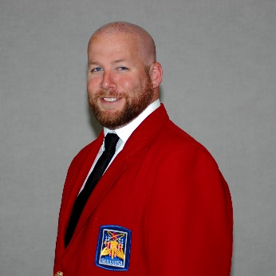
Advisor of the Year 2016
Adam Scroggins, Pierce County Skills Center

Adam has played a leadership role in his school SkillsUSA program and has had a significant impact at the regional and state level. Adam currently serves as a Puget Sound Regional Representative, a SkillsUSA Board member, a SkillsUSA Certified trainer and he oversees our statewide conference scoring.

SkillsUSA Washington - National Leadership & Skills Competition
2016 Medalists / Top 10 Places

Action Skills Octavio Reyes New Market SC 9th Place
Automotive Service Tech Jonathon Ball Aberdeen HS 1st Place (Gold)
Cabinetmaking Tate Boone Auburn Riverside HS 4th Place
CNC Milling Specialist Quentin Roberts Sno-Isle Vocational Skills 2nd Place (Silver)
Community Action Project Cortnie Harrington Davis HS 3rd Place (Bronze)
Community Action Project Emilio Herrera Davis HS 3rd Place (Bronze)
Computer Programming Jack Erb Lewis and Clark HS 1st Place (Gold)
Diesel Equipment Ian Fujinaka Sno-Isle Skills Ctr 6th Place
Digital Cinema Production Trevor Janshen Yakima Valley SC 10th Place
Digital Cinema Production Kyle Roy Yakima Valley SC 10th Place
Electronics Technology Matthew Dickson Auburn Riverside HS 2nd Place (Silver)
Firefighting Hunter Czlapinski Wenatchee HS 2nd Place (Silver)
Information Tech Service Trent Kenny Rogers HS-Spokane 2nd Place (Silver)
Job Skill Demo ‘A’ Clarissa Jenkins North Thurston HS 2nd Place (Silver)
Job Skill Demo Open Taylor Halverson North Thurston HS 4th Place
Major Appliance & Refrigeration Rafael Lopez-Soriano Aberdeen HS 2nd Place (Silver)
Mobile Robotic Technology Dane Driskell Spokane Valley Tech 4th Place
Mobile Robotic Technology Hunter Skoien Spokane Valley Tech 4th Place
Nurse Assisting Molly Hitchens Sammamish HS 2nd Place (Silver)
Photography Ryan Campbell Pullman HS 4th Place
Restaurant Service Karin Taylor Woodland HS 5th Place
Robotics: USR Blake Sackrider Elma HS 10th Place
Robotics: USR Brand Siverts Elma HS 10th Place
Welding Karsten Anderson Pullman HS 2nd Place (Silver)

2015-16 SkillsUSA Washington (2457 total membership)
Membership in 2014-2015 (2330)
Chapter membership followed by increase or decrease from prior year

Aberdeen (48)+17 Arlington (100)+55 Auburn (15)-29
Auburn Riverside (31)-13 Battle Ground HS (6)+2 Bellevue (49)+33
Bonney Lake (4)+4 Bothell (56)+8 Bremerton (19)+9
Capital (4) Cascade (6)+2 Cashmere (16) +16
Central Kitsap (56)-5 Centralia (17)+6 Clark County SC (43)-9
Columbia Basin Tech (6)-21 Columbia River (25)-3 Curtis Senior HS (7)-26
Cusick HS (1) Darrington (21) +21 Davis (30)+3
Decatur (11)-17 Eagle (6)+6 Eastmont (7)+2
Eatonville (13)+13 Edmonds-Woodway (19)+6 Eisenhower (31+9)
Ellensburg (7)-11 Elma (20)-3 Emerald (11)+11
Enumclaw (14)+14 Ephrata (5)+5 Evergreen (30)+15
Ferris (12) Ft. Vancouver (40)-6 Grandview (5) +5
Granger (3)-2 Highland HS (4) Hockinson HS (4)+1
Hudson’s Bay (11)+4 Ilwaco High School (12)+2 Jenkins (71)+4
Kelso (2)+2 Kent Meridian (7)-1 Kentlake (7)+7
Kentridge (21)+3 Lewis & Clark (13)+3 Lincoln (12)+3
Lynnwood (7)-2 Mark Morris (6)-11 Mary Walker (4)
Meadowdale (11)-9 Monroe (2)-1 Moses Lake (15)-12
Mount Si (6)+6 Mount Vernon (3)+3 Mountain View (8)+8
New Market SC (40)+12 Newport (52)+35 NEW TECH SC (26)-14
North Mason (6)-2 North Olympic Penn (6)+6 North Thurston (18)-5
Oak Harbor (5) Olympic (15)-3 Orting High School (5)-2
Orting Middle School (8)+3 Pe Ell District 301 (7) Pierce County Skills Ctr (242)+92
Port Angeles (34)+9 Professional Beauty (18)+12 Prosser (34)+34
Puget Sound SC (143)+33 Pullman (19) Puyallup (10)-1
Quincy High School (8)-7 Rainier (15)+4 Raymond (21)+21
River Ridge (14) Riverside (32)+10 RA Long High School (13)+2
Rochester (9)+9 Rogers Puyallup (7)-2 Rogers Spokane (16)-3
Sammamish (40)+10 SEA-Tech (10)+10 Seattle Skill Center (21)+14
Sedro-Woolley High School (7)-1 Sequim (11)+3 Shelton (9)-9
Skyview (11)-2 Sno-Isle SC (21)-8 South Kitsap High School (5)+4
Spokane Valley SC (34)+8 Stanton Academy (1)-1 Stevenson (5)-1
Sumner (10)+5 Sunnyside (100)+12 Tahoma High School (14)-4
Thomas Jefferson (71)-20 Todd Beamer (12)-11 Tri Tech SC (82)+26
VSAA (18)+18 Wahluke (12)-17 Wa Virtual Academies (18)+6
Wenatchee (21)+10 Wenatchee Valley SC (59)-24 West Sound Tech SC (15)-16
West Valley (17)+5 White River HS (10)+5 Winlock (19)-4
Woodinville High School (8)-3 Woodland (13) Yakima Valley Tech (128)-28
Yelm (11)-1

YOUR CHAPTER GOES HERE

SkillsUSA Chapter Activities

